A

Report

On

Teacher’s Day 2021

Department of PHILOSOPHY

Rabindra Mahavidyalaya, champadanga,hooghly

Session: 2021-22

Theme: TEACHERS DAY

Venue: online mode

google meet

Date: 5TH September,2021

Organizer: Department of Philosophy

Objectives:

- It is a reminder of the role that teachers play in nation-building by guiding and educating the brightest minds of our country.
- Maintaining teacher student relationship even in lockdown, pandemic situation.
- To promote good relationship between teachers and students.
- To Respect the teacher's values

Summary

A Teacher’s Day is organized by the students of Philosophy Department on 5th 2021, on online google meet platform. About 50 students participated in that program. Two hosts Sushovan Maity and Saurav Jana started the program. After that the principal gave the valuable inaugural speech. Then the department head gave a speech. Then started online cultural programs like singing, dancing, drama, recitation etc. On that day, the students performed an Audio-Drama, called ‘MA DURGA AND CONG’. They perform it very beautifully. Everyone enjoys it very much. Through various programs they try to show respect and gratitude to Sarvapalli Radhakrishnan and teachers.

On that day, the students performed an Audio-Drama, called ‘MA DURGA AND CONG’. Various characters in the play were:
- In the role of narrator (kathaker vumikay): Itika Bera (2nd sem)
- In the role of Durga: Sukriti Das (6th sem)
- In the role of Purohit and Mahishasur: Sourav Jana (2nd sem)
- In the role of Lord Shiva: Sushobhan Maity (4th sem)
- In the role of Goddess Saraswati: Rikta Sashmal (2nd sem)
- In the role of Goddess Lakshmi: Kusum Saw (2nd sem)
- In the role of lord Ganesha: Nikita Khanra (2nd sem)
- In the role of lord Kartik: Pijush Kar (6th sem)

Every year we celebrate teacher’s day in college, but this year since the lockdown is going on, we celebrated teachers’ day online mode for the first time. A mixed and strange feeling was working between likes and dislikes and excitement. All in all the program was very well conducted.
Inaugural speech by principal | speech by Dept. Head prof. Hasina Sikdar
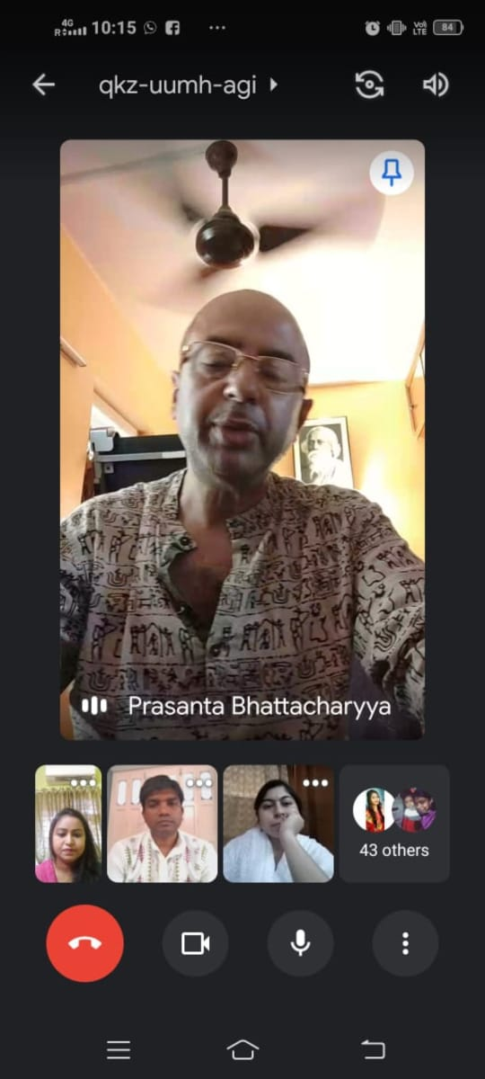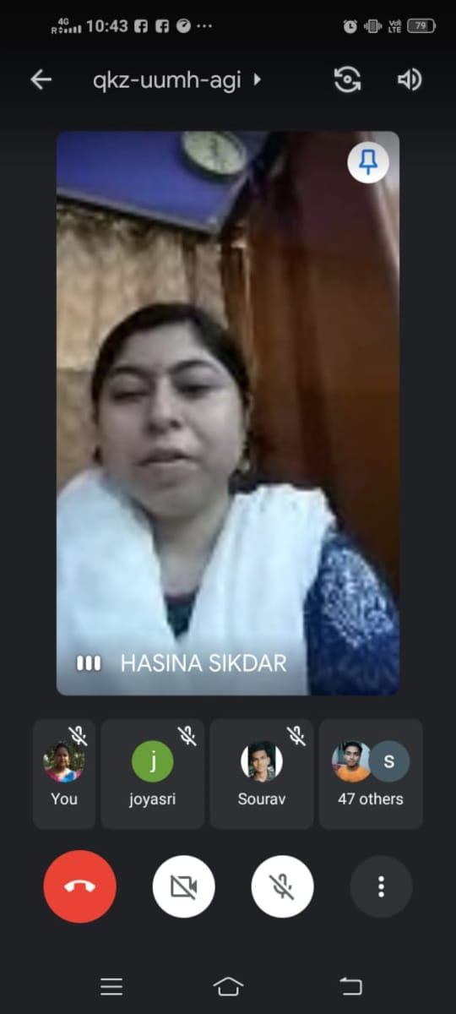

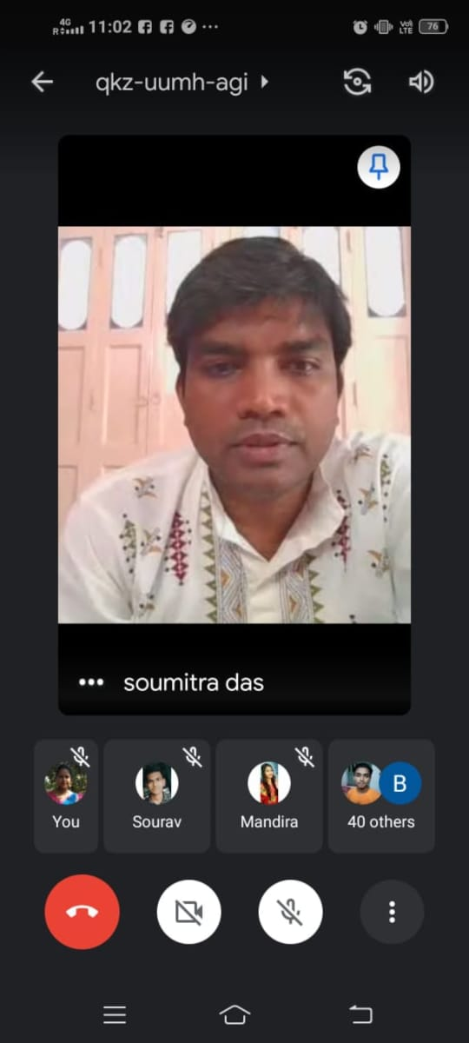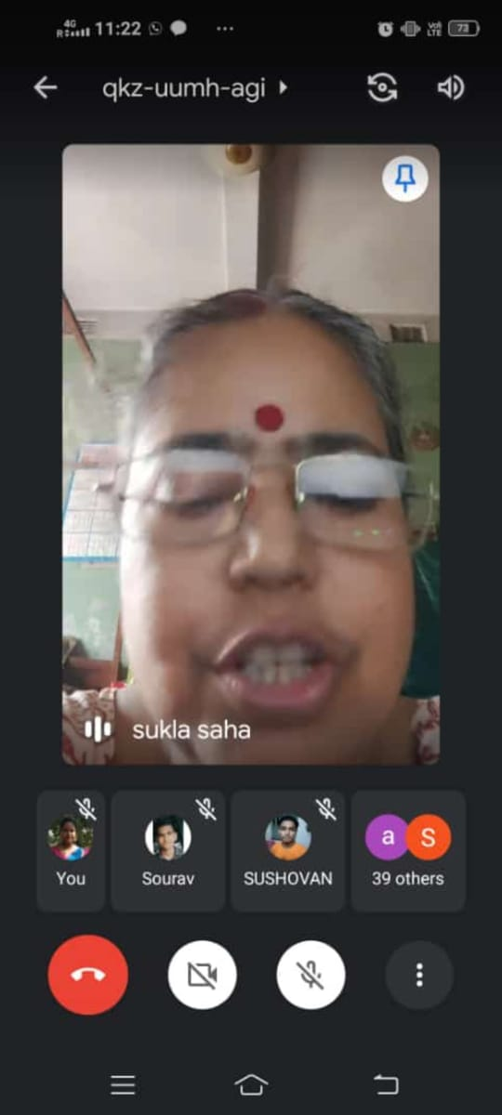
speech by Department prof. Soumitra Das and prof. Sukla Saha
Prof. Sanchita Kheto sang a song | Prof. Soumitra Das’s daughter Averi Das performed a recital
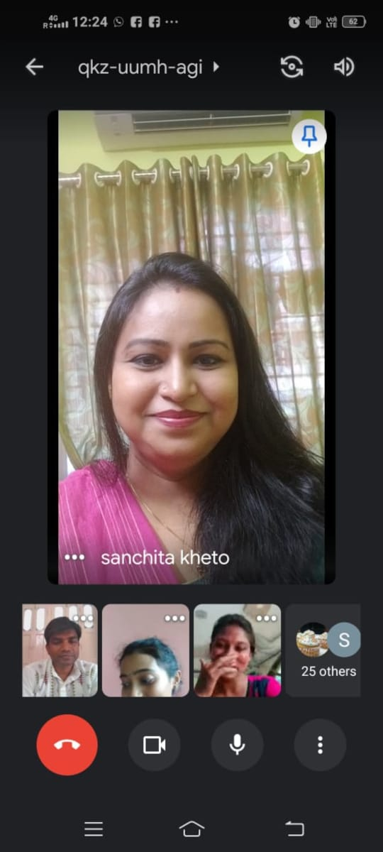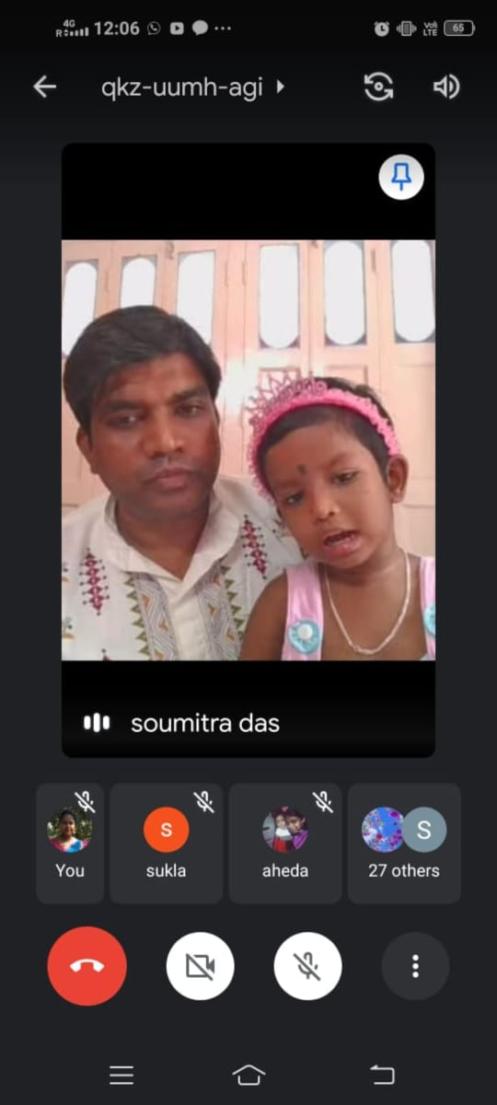
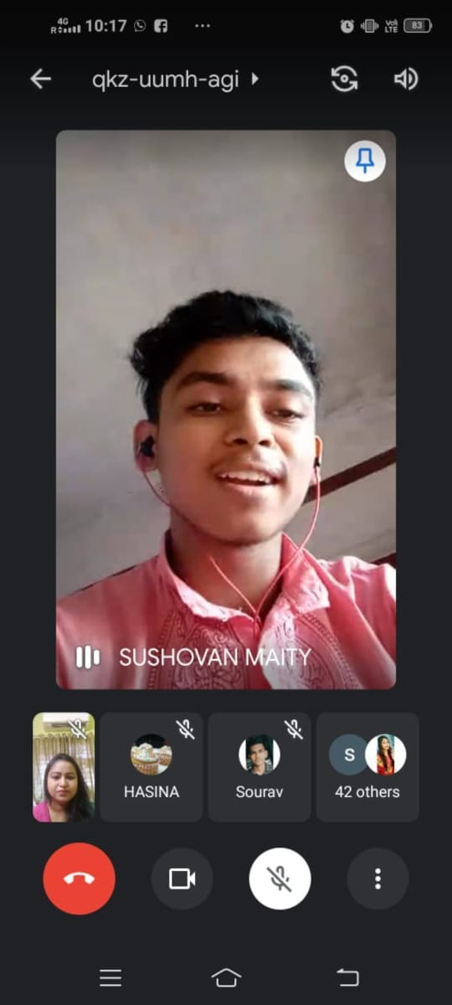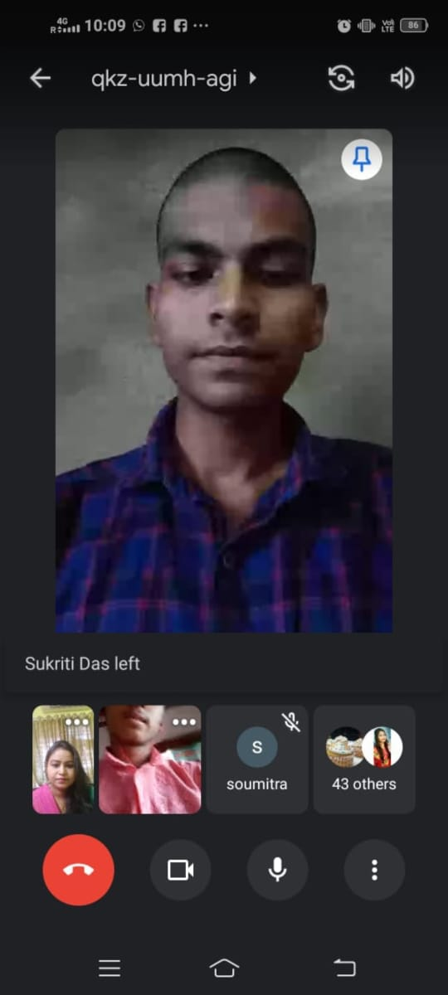
program hosts
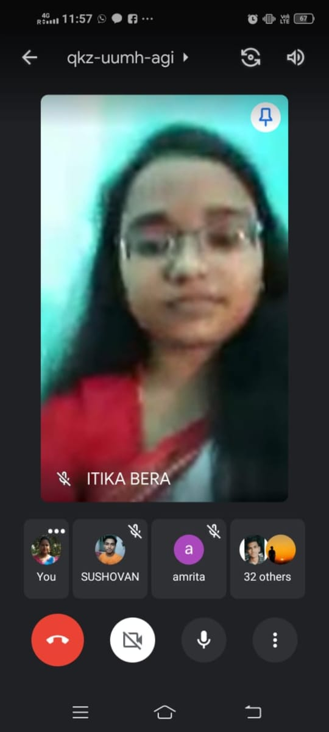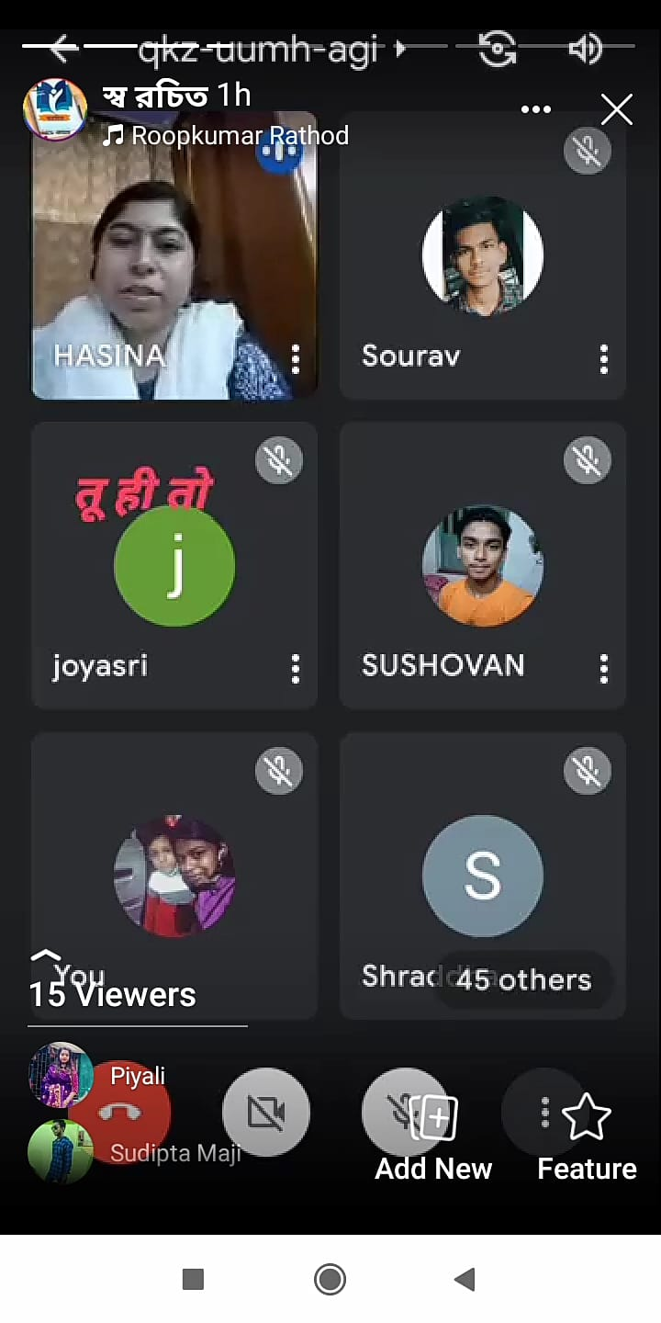

Our perticipent: 50
Male:20
Female:30

Tentative programme schedule
- Inaugural session: 10 .00a.m. to 10.30 a.m.
- Inaugural Speech: 10.30 a.m. to 11.00 a.m.
- Cultural programme: 11.00 a.m. to 1.30 p.m.

Feedback from studend:
- 50% felt satisfactory
- 70 percent wished to be celebrated the event physically at the college

